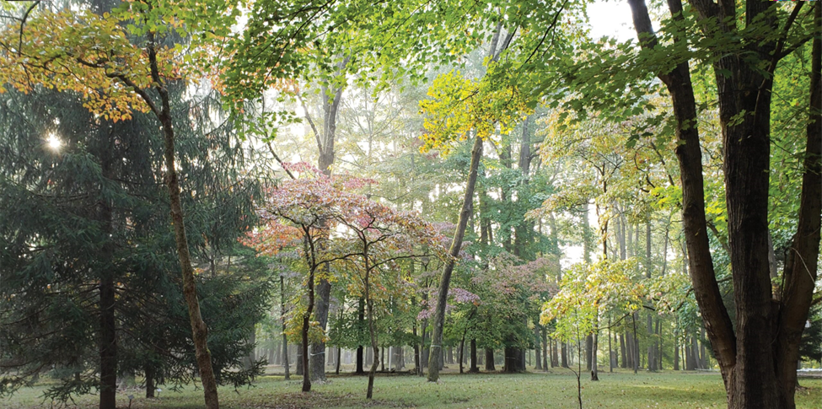

Schuylkill Township

Open Space Commission Agenda

August 25, 2025
AMENDED AGENDA

Executive Session Begins at 6:45pm

Public Meeting Starts at 7:00 pm

Call to Order

Approve Minutes: from meeting held on June 30, 2025

Property Outreach

Treasurers Report

Old Business

New Business

- Motion by Tim McAvoy and seconded by Kathi Lex and passed unanimously to Amend the Agenda to Add a Discussion Item on the 2026 Budget.

- Discussion on 2026 Open Space Commission Budget

